PROJECT TITLE
Diabetes Prevalence Analysis using Excel & Power BI (2020–2022)

1. Project Overview and Objective
Project Overview
This project focuses on cleaning, transforming, and analysing global diabetes prevalence data using Microsoft Excel and developing an interactive dashboard in Power BI. The analysis examines diabetes prevalence across different countries, regions, age groups, genders, and years (2020–2022) to identify meaningful trends and patterns.
Objective
- To clean and prepare the dataset using Excel.
- To analyse diabetes prevalence by region, country, age group, gender, and year.
- To build an interactive Power BI dashboard for easy data exploration.
- To derive meaningful insights that support healthcare-related decision-making.

2. Data Source
Source: World Health Organization (WHO) Global Health Observatory
Timeline: 2020–2022
Domain: Healthcare / Public Health Analytics
3. Problem Statement
The objective of this project is to analyse diabetes prevalence across different countries and WHO regions from 2020 to 2022. The project aims to identify trends by age group, gender, region, and year, determine the most and least affected countries, and present the findings through an interactive Power BI dashboard.
4. Attribute Details
ATTRIBUTE | DATA TYPE | DESCRIPTION
COUNTRY | TEXT | NAME OF COUNTRY
REGION | TEXT | WHO REGION
YEAR | INTEGER | 2020-2022
GENDER | TEXT | MALE, FEMALE, BOTH
AGE | GENERAL | 30+,18+ YEARS
PERCENTAGE OF PEOPLE AFFECTED | DECIMAL | DIABETES PREVALENCE (%)
5. Tools & Technologies
Microsoft Excel
- Data Cleaning
- TRIM
- Find & Replace
- Sorting & Filtering
- Pivot Tables
Power BI
- Data Modelling
- DAX Measures
- KPI Cards
- Charts
- Interactive Dashboard
- Slicers & Filters
6. Data Pre-Processing (Excel / Power Query)
Tasks Performed
Data Cleaning
- Removed unnecessary spaces using TRIM.
- Standardized Age and Gender values using Find & Replace.
- Checked for missing values.
- Removed unnecessary columns.
- Verified data consistency.
Pivot Table Analysis
Created Pivot Tables for:
- Region-wise analysis
- Age-wise analysis
- Gender-wise analysis
- Year-wise analysis
- Region vs Year analysis
- Country vs Region vs Year analysis
- Top 10 affected countries
- Bottom 10 affected countries
7. Data Modelling and DAX (Power BI)
Data Model
- Imported cleaned Excel data into Power BI.
- Verified appropriate data types.
- Created measures for dashboard KPIs.

DAX Measures
Average Percentage =AVERAGE ('Diabetes prevalence analysis'[Percentage of People Affected])
Highest Percentage =MAX ('Diabetes prevalence analysis' [Percentage of People Affected])
Lowest Percentage =MIN ('Diabetes prevalence analysis'[Percentage of People Affected])
Total Countries =DISTINCTCOUNT ('Diabetes prevalence analysis' [Country])
Total Regions = DISTINCTCOUNT ('Diabetes prevalence analysis' [Region])
8. Analysis and Visualizations (Power BI)
Dashboard Features
KPI Cards
- Average Diabetes Prevalence
- Highest Prevalence
- Lowest Prevalence
- Total Countries
- Total Regions
Visualizations
- Clustered Bar Chart – Top 10 Countries by Diabetes Prevalence
- Clustered Bar Chart – Bottom 10 Countries by Diabetes Prevalence
- Line Chart – Year-wise Diabetes Trend
- Tree map – Region-wise Diabetes Prevalence
- Pie Chart – Age-wise Diabetes Prevalence
- Stacked Bar Chart – Gender-wise Diabetes Prevalence
- Column Chart – Country-wise Diabetes Prevalence
Interactive Features
- Year Slicer
- Region Slicer
- Gender Slicer
- Age Slicer
- Cross-filtering between visuals
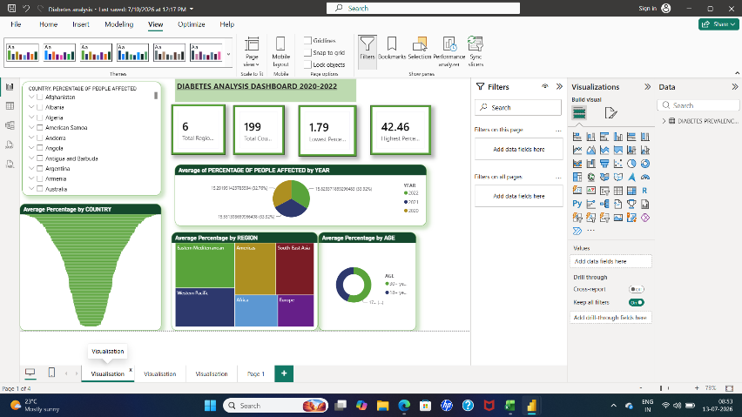
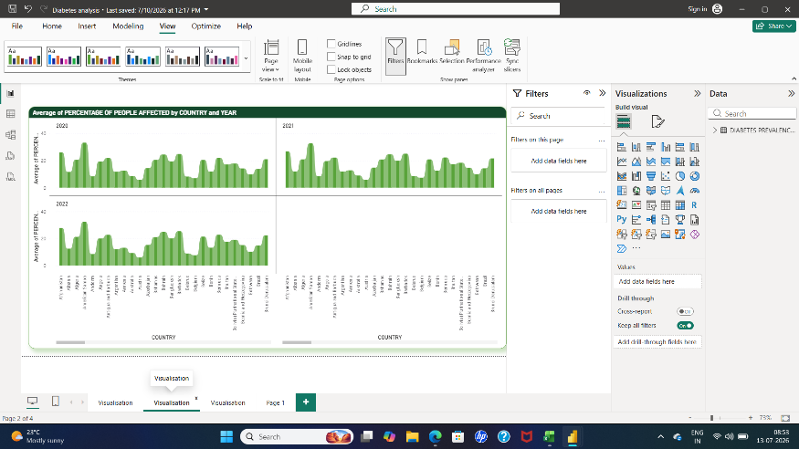
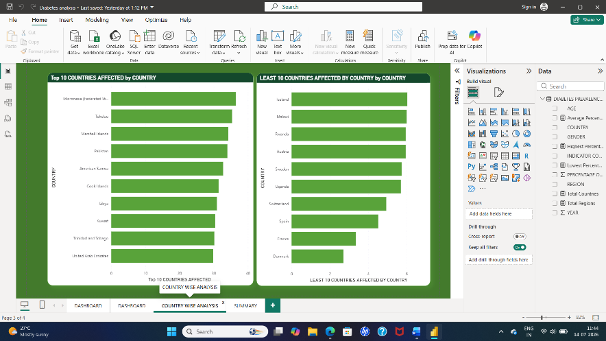
9. Insights & Conclusions
Key Findings
- Diabetes prevalence increased gradually from 2020 to 2022.
- Eastern Mediterranean recorded the highest average diabetes prevalence.
- Europe recorded the lowest prevalence.
- Adults aged 30+ years had higher prevalence than the 18+ years group.
- Female prevalence was slightly higher than male prevalence.
- Diabetes prevalence varied significantly across countries.
- Analysed diabetes prevalence by year, region, country, age group, and gender.
- Identified Top 10 and Bottom 10 countries by prevalence.
- Compared prevalence across WHO regions.

- Compared prevalence across age groups, genders, and regions to identify patterns.
Why is the Eastern Mediterranean Region more affected?
Analysis shows that the Eastern Mediterranean region has the highest average diabetes prevalence.
Possible reasons:
- High prevalence of obesity and overweight, which are major risk factors for Type 2 diabetes.
- Sedentary lifestyles due to reduced physical activity and urbanization.
- Unhealthy dietary habits, including high consumption of sugary drinks, processed foods, and calorie-dense diets.
- Higher rates of hypertension and metabolic syndrome, which often occur alongside diabetes.
- WHO notes that 6 of the world's 10 countries with the highest diabetes prevalence are in the Eastern Mediterranean Region, highlighting the region's exceptionally high burden.
Why is Europe less affected?
Dashboard shows Europe has the lowest average prevalence.
Possible reasons:
- Better healthcare infrastructure and easier access to screening.
- Greater public awareness about diabetes prevention.
- Earlier diagnosis and treatment programs.
- Better management of lifestyle-related risk factors in many European countries, although diabetes remains a significant public health issue. WHO also emphasizes prevention through healthy diet, physical activity, and weight management.

Based on the trend observed from 2020–2022:
- Diabetes prevalence remains consistently high in the Eastern Mediterranean region.
- Countries such as Pakistan, Tokelau, Mauritius, and Trinidad & Tobago are likely to continue showing high prevalence if current lifestyle and health patterns persist.
- The 30+ age group is expected to remain the most affected population segment in the coming years.
- If preventive measures are not strengthened, diabetes prevalence may continue to increase globally due to urbanization, obesity, and sedentary lifestyles.
What should be done?
Based on the findings, the following actions may help reduce diabetes prevalence:
- Increase screening and awareness programs in high-prevalence regions.
- Promote physical activity and healthy diet initiatives.
- Focus preventive healthcare on the 30+ age group, which showed higher prevalence.
- Strengthen primary healthcare and early diagnosis programs.
- Monitor high-risk countries regularly using data dashboards.

10. Conclusion
This project successfully combined Excel and Power BI for end-to-end healthcare data analysis. Excel was used for data cleaning, transformation, and Pivot Table analysis, while Power BI was used to build an interactive dashboard with KPI cards, slicers, and visualizations. The analysis revealed that the Eastern Mediterranean region had the highest diabetes prevalence, Europe had the lowest prevalence, and the 30+ age group showed consistently higher prevalence than the 18+ group. The project demonstrates practical skills in data preparation, DAX calculations, visualization, and insight generation for decision-making.

